Celect chip programming P/N’s 4473, 8046, 9037

1. ecm serial number is store on two xicor chips
- serial number is split into two parts and stored at the end of the bin file

2. example: serial number 662668
- computer splits numbers by position odds and evens
- 1, 2, 3, 4, 5, 6 odds and evens would line up like this on serial number
- 6, 6, 2, 6, 6, 8 - computer has room for 8 digits but usually only use 6

HIGH xicor gets odds or number positions 1,3,5 = 626
LOW xicor gets evens or number positions 2,4,6 = 668
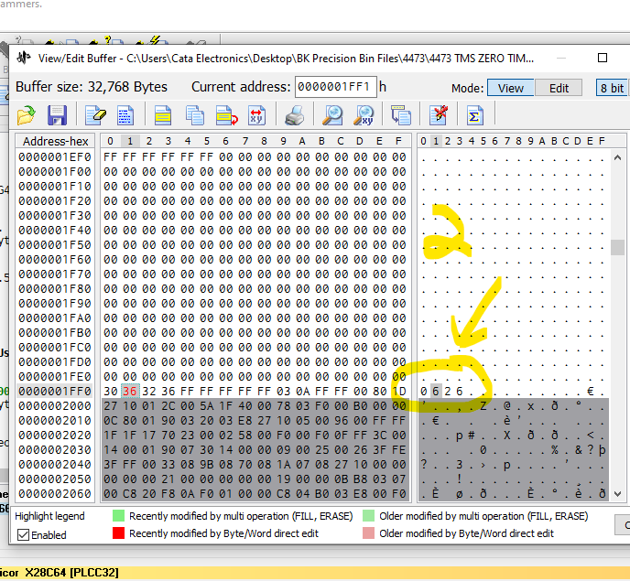
HIGH xicor would get numbers
- 626

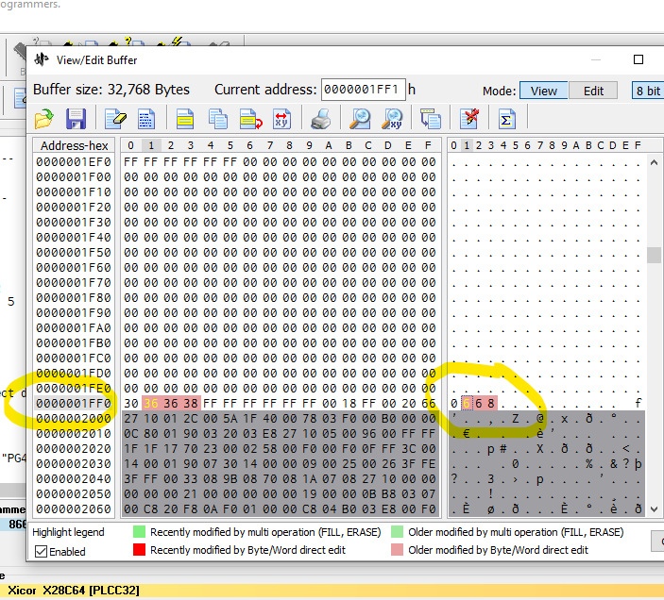

LOW xicore would get numbers
- 668

3. TMS or AT27C256R do not get modified only programmed with there respective HIGH and LOW

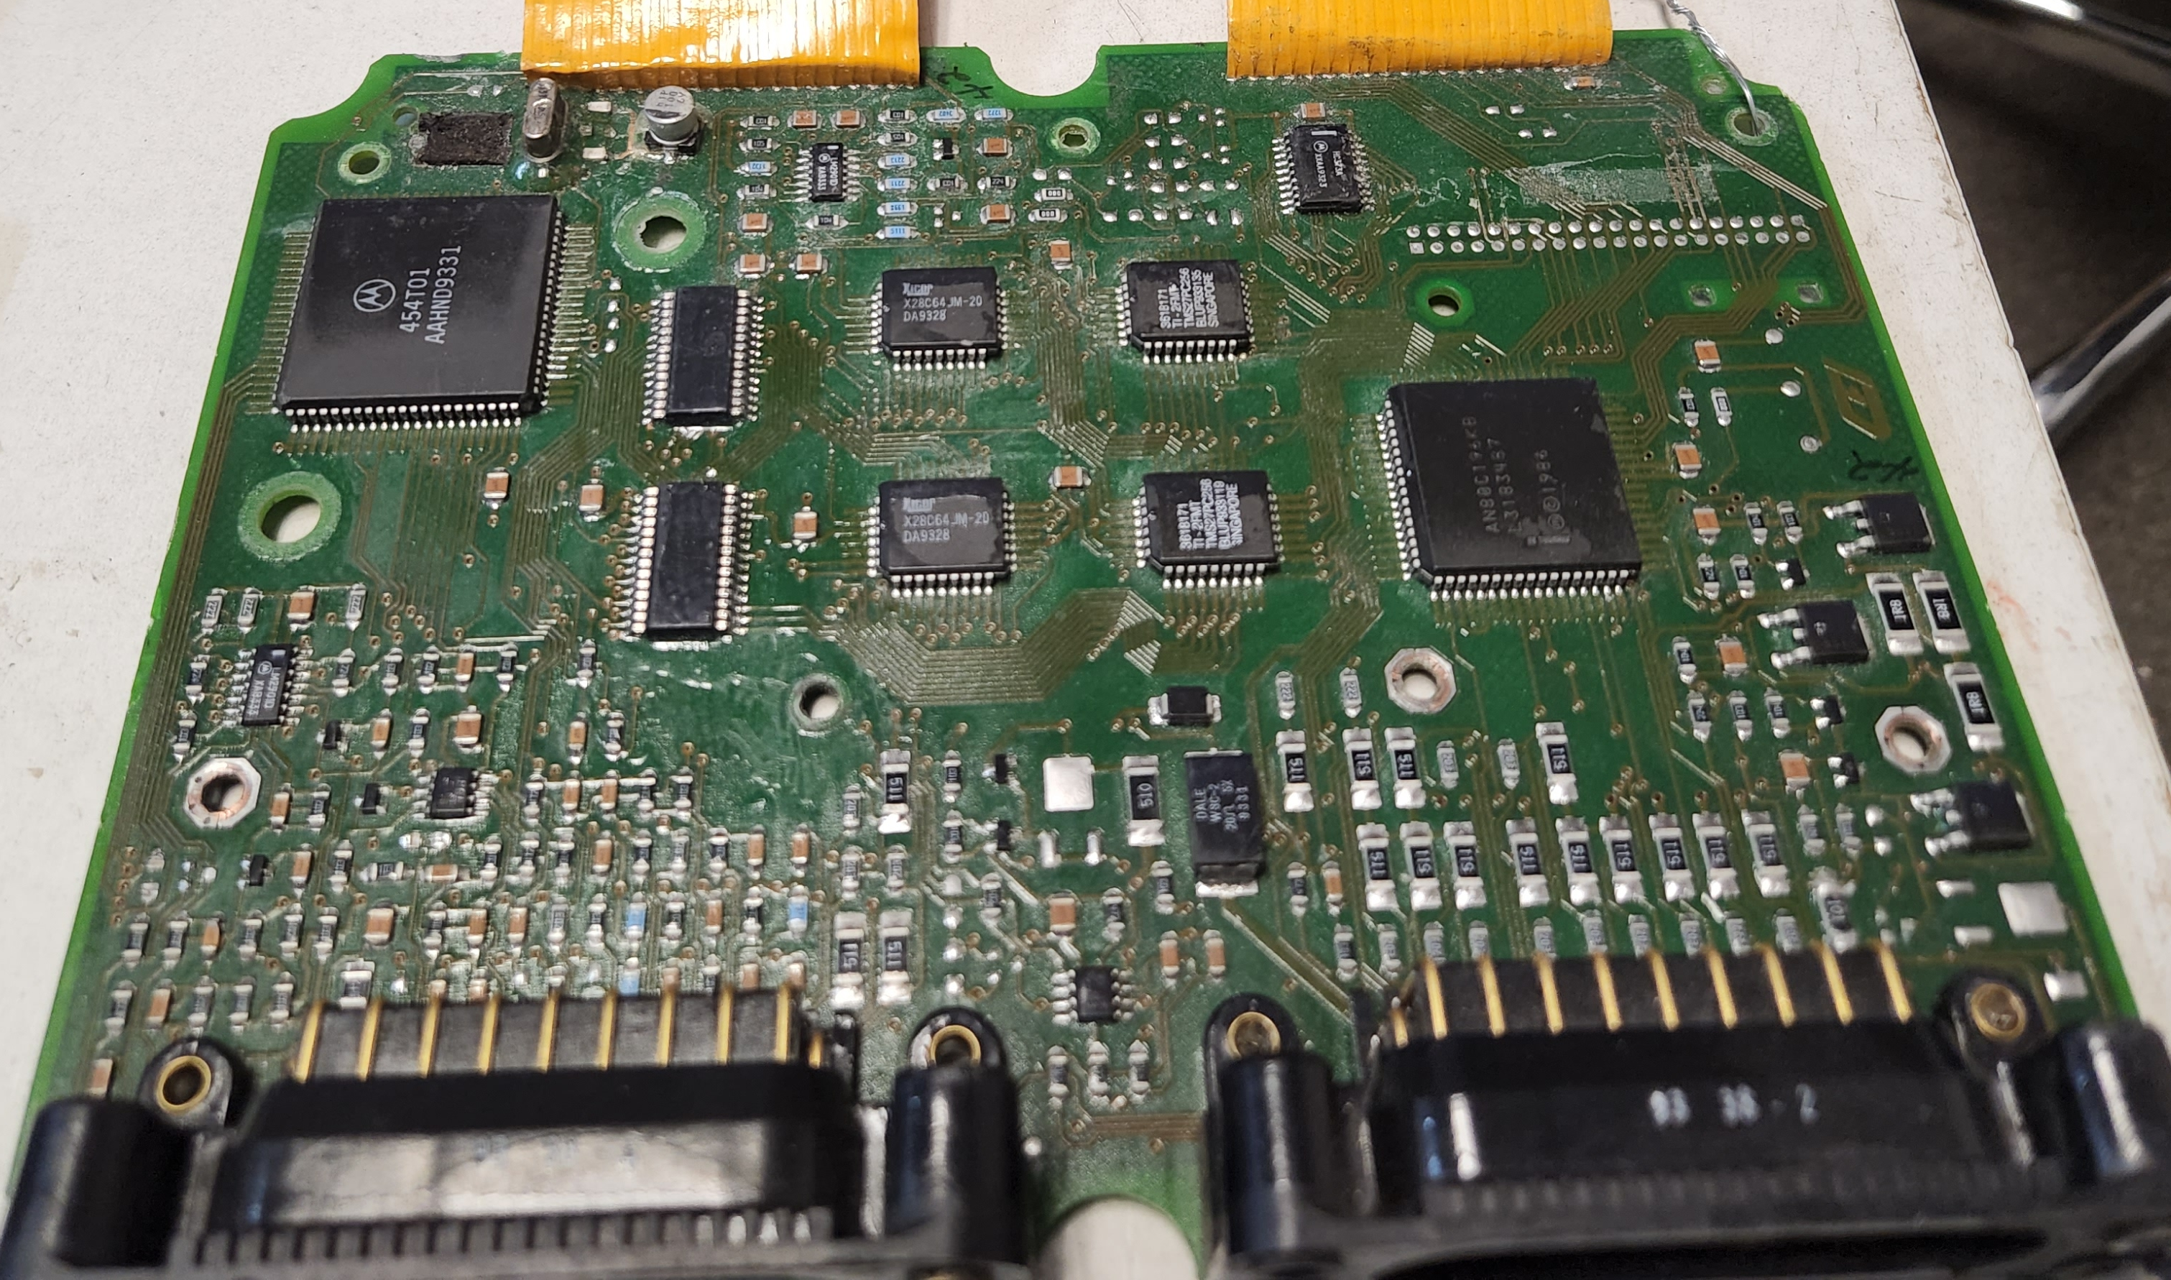
HIGH
LOW
-TMS27 or
-AT27C256R
HIGH
LOW
-X28C64 or
-AT28C64

